The Coffee Shop Project Design

Revision History

|  |  |  |  |
| --- | --- | --- | --- |
| **Date** | **Issue** | **Description** | **Author** |
| <21/12/17> | <1.1> | Initial draft with User Management and Spring Security | Vinh Hoang |
|  |  |  |  |
|  |  |  |  |
|  |  |  |  |

Table of Contents

1. Introduction 2

1.1 Purpose 2

2. Requirements - Use-Case – Usage Scenarios 2

3. High Level Design 2

4. Detailed Design 2

4.1 <Object.Name> Usage 2

4.2 Interaction Diagram 2

5. Issues, Risk and Dependencies 2

6. Design Alternatives 2

7. References 2

# Introduction

The MUM Coffee Shop wants to automate their management process, and have delegated the development of the system to team “SaFaVi” . Specifically, they want to develop a web application allowing their customers to order coffee or snack and get managed the orders. The system needs to be secured, and allows only authorized accesses. The following requirements are provided:

The system needs to support three roles: guests, members and *administrator.*

* The guests can see products are available and their details including their prices.
* The Members can login and have access to order products
* The administrator must be able to manage products, users and orders.

## Purpose

The main purpose of this system is to create an application to give customers a function to order the things they want from their fingertip.

# Requirements - Use-Case – Usage Scenarios

*Describe the set of scenarios and/or use cases that represent some significant, central functionality.*

# High Level Design

[In this section, explain in a few sentences what each entity does. Describe your reasoning for defining the entities in your diagram and what their roles are.]

Figure 1 < High Level Design Diagram >

# Detailed Design

[This section is where your objects and object relationships are defined.

## ****<Object.Name> Usage****

[This section is where your objects and object relationships are defined. Describe how the object is used and what function it serves. If an object will interface with an external object or system, it is a good idea to show the interface for the object. Most importantly, you must again describe your thought process for defining the object as you did. List the benefits and risks. If an object provides an encapsulation, describe in a sentence why the encapsulation adds value. Use your descriptions to give meaning to the diagrams.

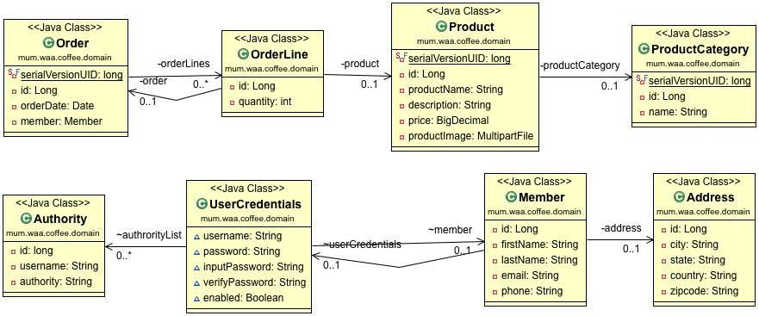

Figure 2 <2 Domain Object Class Diagram>

## ****Interaction Diagram****

[An interaction diagram shows how a set of objects or entities communicate with each other to perform a complex task.]

### User Management

#### User Registration

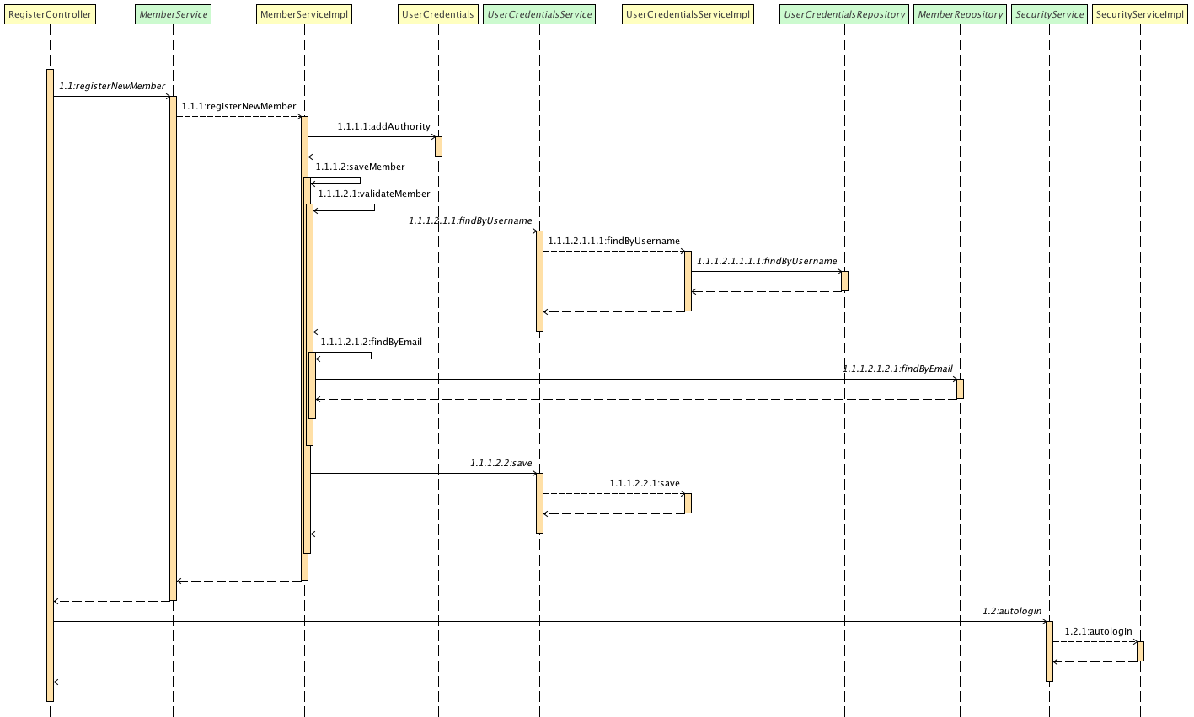

Figure 4 <User Registration Sequence Diagram>

#### Delete User

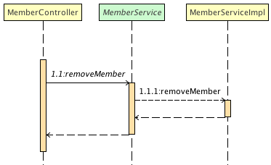

Figure 3 <Delete User Sequence Diagram>

4.3.

Sequence Diagrams

1- Make order

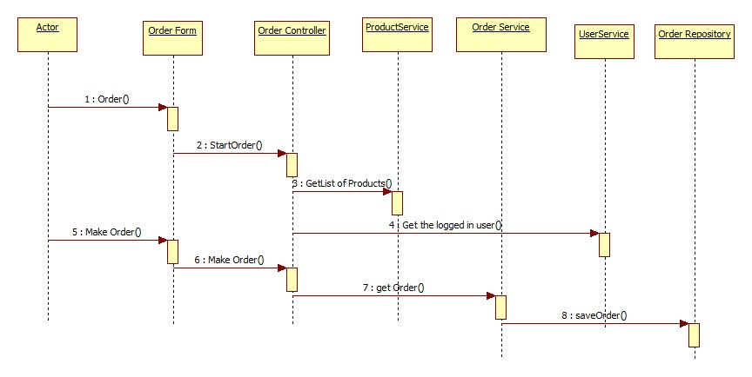

2- Show All Orders

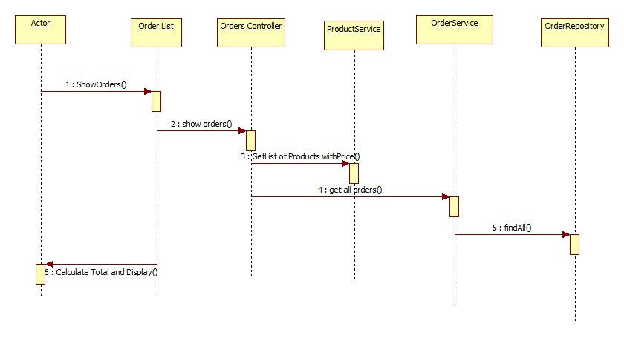

# Design Alternatives

[This section describes alternative designs that were considered. ]

# Issues, Risk and Dependencies

[All known risks/issues and a list of all assumptions/Dependencies. Some of this may simply be rehashing what you wrote in a previous section of the document.

What’s important is getting all of these items into one section so that the reader doesn’t have to read the whole document to understand what the benefits, risks and assumptions are.

# Issues and Experience Sharing

* Auto login after registration: Initially, I used springSecurityFilterChain, as following:

<filter-mapping>

<filter-name>springSecurityFilterChain</filter-name>

<url-pattern>/login/auth</url-pattern>

<dispatcher>FORWARD</dispatcher>

</filter-mapping>

But It didn’t work, so I changed to used AuthenticationManager instead.

# Future Considerations

- For the Future we will do Adding to Cart and the make the orders from there.

# References

[This subsection provides a complete list of all documents referenced. Identify each document by title, report number (if applicable), date, and publishing organization. Specify the sources from which the references can be obtained. This information may be provided by reference to an appendix or to another document.]